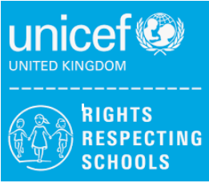
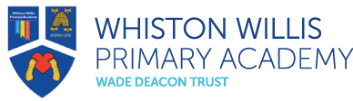
Rights Respecting Schools
June 2023 Newsletter

Welcome to our Rights Respecting Schools monthly newsletter! We are currently a Silver Rights Respecting School, working towards becoming Gold. We aim to learn about children’s rights and put them into practice every day. We work towards this goal together with the children, making a positive impact on the whole school community.

Article of the Month
Each month we will be choosing an article of the month to focus on in assemblies and discussions in class. We hope to widen children’s understanding of their rights and develop their knowledge.

This month our Pupil Leadership Team chose Article 32 – you have the right to protection from work that harms you, and that is bad for your health and education.
June is Child Labour Awareness month so our team thought this was an ideal article to focus on.

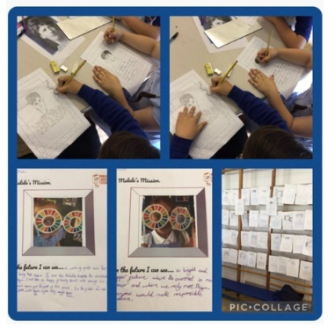
Pupil Conference
This month we organised our very first Pupil Conference Day with Prescot Primary.
We invited other local primary schools to join us and had a fantastic day meeting lots of new friends. The day focused on our Rights Respecting schools work and we learnt about the beginning of children’s rights. We thought about the Global Goals and completed some work on what we would like the world to look like through our own eyes.
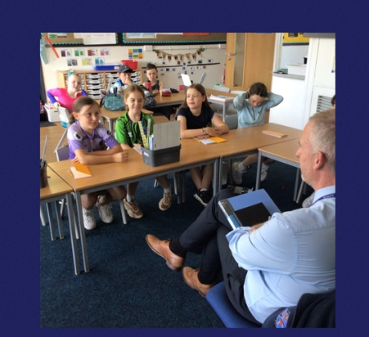
Pupil Leadership Meetings
Our after-school club have had a very successful half term. We have been discussing changes we wish to make in school and have been thinking about our behaviour policy. The children met with Mr Cooper to discuss their ideas and opinions about the policy and what changes they would like to see happen.
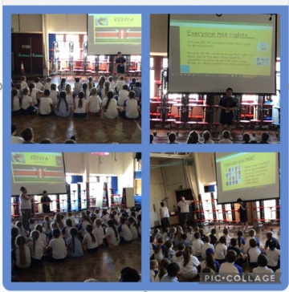
Campaigning
Thank you to everybody for your support with our current campaign supporting a school in Kenya. Our Pupil Leadership have met to discuss what equipment the school will benefit from most and will get to deliver the equipment to our former pupil so it can be taken to Kenya in October.
Thank you for your continued support

Mrs A. Askew and the Pupil Leadership Team

