
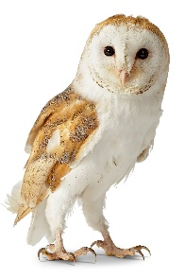

Reception Class Newsletter
03.10.2025
The weeks are passing by quickly and the children in reception are all settling well and our routines for learning are well established. Children are now enjoying the full curriculum and growing in confidence every day. Children continue to be supported with positive relationships and are making us proud.

Phonics
This week the children have been fully immersed into lessons. During phonic lessons children have learnt the sounds “c. k, u, b, f” and we have now provided all children with reading records. Please use the QR codes to watch the Virtual Classroom of the sounds taught each day. The children are also now forming letters correctly and we will send home our RWI Handwriting next week.

Literacy
Within Literacy, our focus story is, Bringing the Rain to Kapiti Plain. The children have had the opportunity to look at Africa and role play key features of the story. We have begun to build words for writing and have had lots of opportunities to Fred Talk the sounds in words.

Maths
For Maths, children have been Composing and de-composing numbers, which involves children investigating part–whole relations. e.g. seeing that 3 can be composed of 1 and 2. We have also looked at repeated pattern in provision using natural resources.

General
Our PE day is a Monday. Children come into school dressed in their PE kits on this day.
Please do not put drinks beakers in book bags as the reading records get wet and become damaged.
Please send a pair of wellies into school so that children can access the outdoor area in all weathers.

Reminders
Please remember snack is £1 a week. This can be paid weekly or termly.

Please ensure your child has their name written in all items of clothing including coats, shoes and bags. This would help us to prevent any pieces of clothing from being misplaced or lost.

We are a healthy school so please ensure packed lunches are containing healthy food and drink items where possible.

Thank you for your continued support
Mrs Halsall
Miss Chiocchi

