PTA Newsletter
December 2023

Welcome to our PTA Newsletter! Our PTA team is up and running with regular meetings being held and plans in place for the upcoming year. Each month we will provide you with a newsletter to update you on our successes and future plans.
Our main aims for this year are to plan half termly activities for the children to begin fundraising for our school community. We are aiming to raise enough funds for each class to have an extra-curricular experience to enhance their curriculum learning.
Christmas Movie Night
Our first PTA event was a huge success! The children loved returning to school in their comfy clothes to watch their favourite movies and lots found it very funny to be back at school when it was very dark!
The event raised over £500 and every penny will be spent on extra-curricular experiences for our pupils.
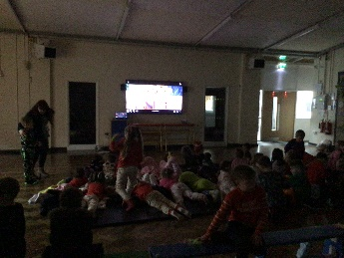
A big thank you to all involved in the organisation and for all your support.
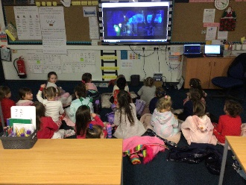
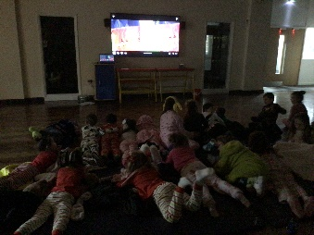

Dates for your diary
Thursday 8th February – Valentine’s Disco

Join our PTA Team!
We are looking to expand our team of parents who can give some time to support our school community. If you are interested, please call into the school office and speak to Karen who can direct you to a member of staff involved. Let’s work together to make a positive impact on our school community!

Our next meeting will take place on Thursday 11th January at 2.15pm. Please turn up to the school office at this time if you wish to join us.
Thank you for your continued support

The PTA Team

