10TH October 2025
Dear Parents/Carers,
It has been another busy two weeks since our last whole school newsletter and there have been many many successes academically and pastorally for our children in school.
Parking continues to be an issue around school and we continue to ask you to park safely and protect all the children in our school community. Our signs outside of the front of school on Milton Avenue are there to ensure that there is a safe space for pupils and families to cross Milton Avenue without vehicles obstructing their view. We recognise the new parking regulations have come into force and we have no control over this however as a school community the safety of all our pupils should be of upmost importance for us all. Please do drive slowly and safely in and around school. Inconsiderate and unsafe parking can pose a risk to all our pupils.
Today our pupils have celebrated World Mental Health Day. They have learned about ways that they can support their own mental health.
We have had football teams represent us in the last two weeks at the Prescot Football League and In a Girls Football Competition. Both teams of children represented the team exceptionally well, played with great skill and teamwork and represented the school in a sporting manner. The team in the Prescot League won all three of their fixtures and are currently joint top of the league.
If you know any families who are looking for a Reception place for September 2026, please let them know we have two upcoming open evenings. The first is next Tuesday on 14th October at 3.30pm and the second is on Tuesday 18th November at 3.30pm. Please encourage any prospective parents to register via the link on the school Facebook page.
A big thank you to all who contributed to our harvest food collection. We have held assemblies for our KS2 children this week with Rev. Andy Telfer and he was very appreciative of the donations made for local families. We always want the children to see the value of helping other people who are less fortunate than perhaps they are and realise that every little helps.
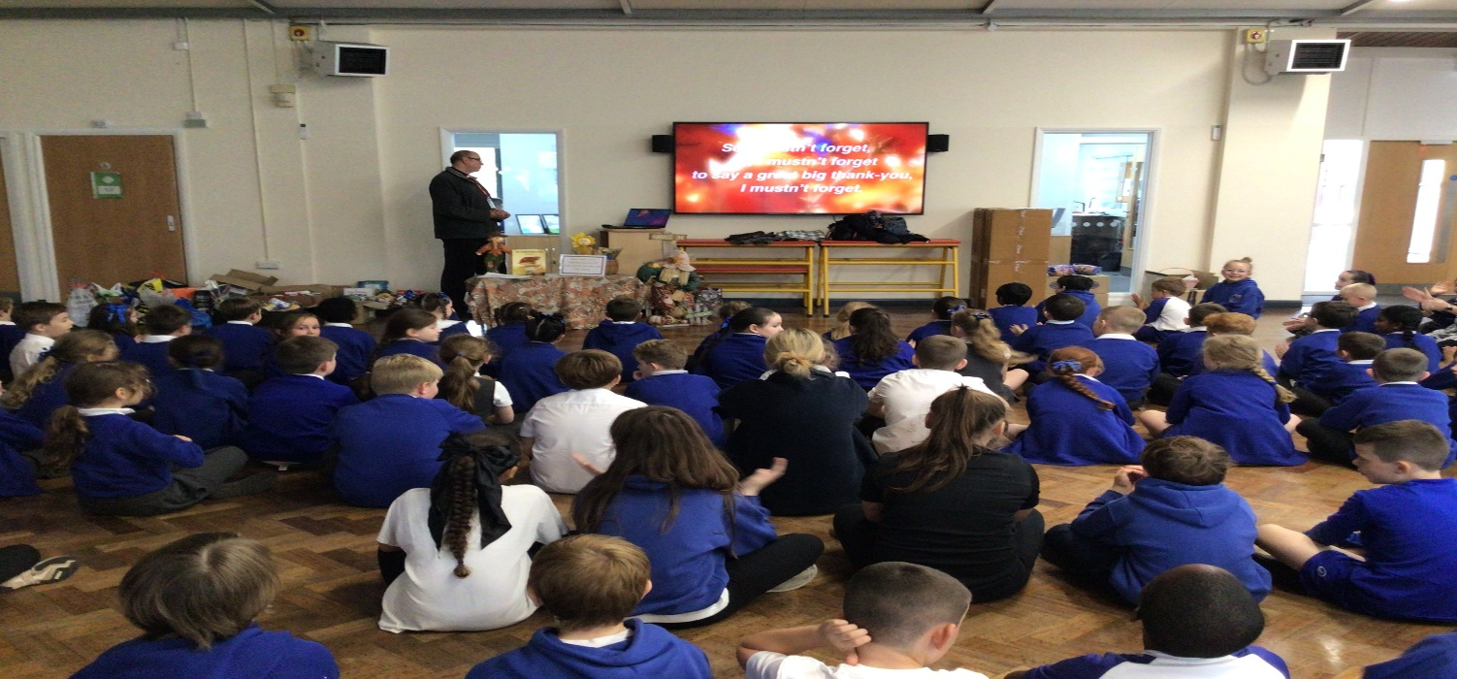

Attendance:
It is vital for all pupils to have strong attendance to give themselves the very best opportunities to build and maintain relationships with their peers and to ensure they have consistency in their learning so that they achieve well.
Learning in school takes place from 8.50am until the end of the school day so punctuality and completing the school day every day is also vital to reduce lost learning.

Attendance League Table (Year to date)
Position | Class | Percentage |  | Please arrange appointments out of school time or if that isn’t possible bring your child in first thing to get their mark and return them after any appointment.  Please do call the school office if your child is going to be absent or if you need any further advice.  Last year our school attendance was below both national and Local Authority figures and must improve. Please support us by arranging appointments outside of school time and getting the children into school regularly this year
1st | Tiger | 97.4% | Y1 WINNERS
2nd | Wolf | 97.2% | Y6 WINNERS
3rd | Owl | 97.0% | EY WINNERS
4th | Pangolin | 96.6% | Y2 WINNERS
5th | Hummingbird | 96.1%
6th | Shark | 95.9% | Y4 WINNERS
7th | Jaguar | 95.8%
8th | Penguin | 95.5% | Y3 WINNERS
9th | Hedgehog | 95.4%
10th | Koala | 95.3%
11th | Leopard | 95.0%
12th | Zebra | 94.0%
13th | Cheetah | 94.0%
14th | Lion | 92.4%
15th | Squirrel | 85.8%

Special mentions for positively standing out this week……
CLASS | PUPIL | Well done to all our pupils who have been recognised by staff this week for their hard work and in following our school values and The Whiston Willis Way.
Squirrel | Bella G and Lara P
Owl | Joel and Dolly May
Hedgehog | Mani A and Lennie C
Tiger | Charlie and Ivy
Jaguar | Esme S and Freya W
Pangolin | Oscar M and Nancy C
Hummingbird | Carson P and Hollie E
Zebra | Thomas F and Kevin D
Penguin | Sonny and Jules
Lion | Finley D and Isla- Rose H
Shark | Freddie S and Sofia W
Koala | Seth and Scott
Leopard | George and Aria
Wolf | Alex O and Lucy Mc
Cheetah | Jude M and Tosin M

Kind Regards,
Ian Cooper

