Rights Respecting Schools
February 2023 Newsletter

Welcome to our Rights Respecting Schools monthly newsletter! We are currently a Silver Rights Respecting School, working towards becoming Gold. We aim to learn about children’s rights and put them into practice every day. We work towards this goal together with the children, making a positive impact on the whole school community.

Article of the Month
Each month we will be choosing an article of the month to focus on in assemblies and discussions in class. We hope to widen children’s understanding of their rights and develop their knowledge.

This month our Pupil Leadership Team chose Article 14 – the right to choosing your own religion and beliefs.

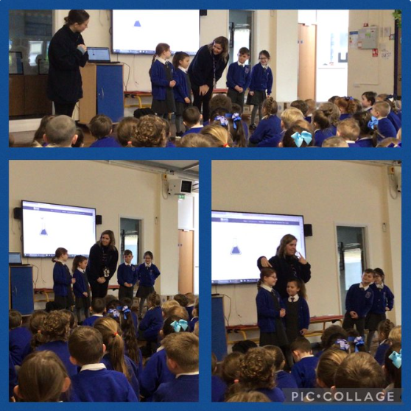
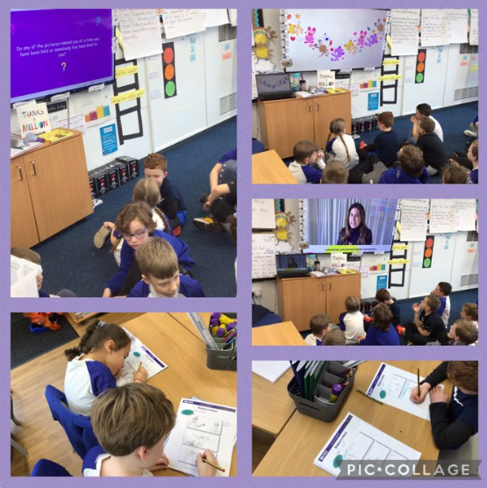
Children’s Mental Health Week
For Children’s Mental Health Week, we focused on the theme of Kindness. We have been thinking about how kindness can make not only others but ourselves feel and how kindness is contagious. We know about our right to choosing our own friendship groups and how we can spread kindness to others.

Pupil Leadership Coffee Afternoon
A massive thank you to all our parents who came to our coffee afternoon held by our Pupil Leadership Team. The children loved sharing their knowledge of being a rights respecting school and handing out their very own leaflets about this.
Many thanks for your donations. We raised £60 which will be given to a children’s mental health charity.

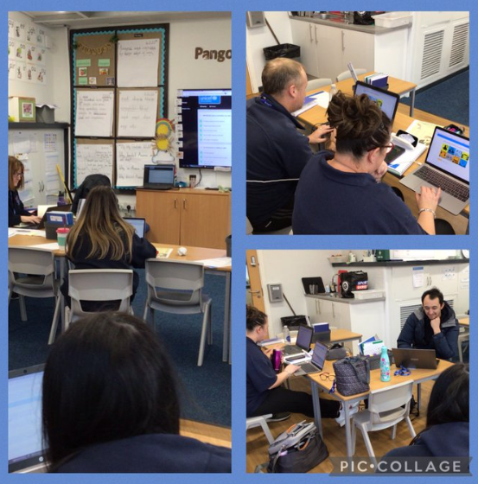
Staff Training
Our staff are all committed to our journey in becoming a Gold Rights Respecting School. We have all been completing CPD to develop our understanding further and ensure children’s rights our embedded throughout the school daily in a consistent approach.
We have lots of plans for fundraising this half term, including an Easter Raffle. Watch this space!

Thank you for your continued support

Mrs A. Askew and the Pupil Leadership Team

