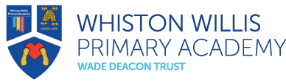
Rights Respecting Schools
May 2023 Newsletter

Welcome to our Rights Respecting Schools monthly newsletter! We are currently a Silver Rights Respecting School, working towards becoming Gold. We aim to learn about children’s rights and put them into practice every day. We work towards this goal together with the children, making a positive impact on the whole school community.

Article of the Month
Each month we will be choosing an article of the month to focus on in assemblies and discussions in class. We hope to widen children’s understanding of their rights and develop their knowledge.

This month our Pupil Leadership Team chose Article 30 – you have the right to practise your own culture, language and religion.

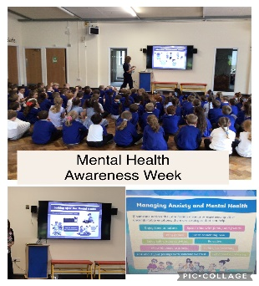
Mental Health Awareness Week
As part of Mental Health Awareness Week, we thought about ways of looking after our mental health and ways to manage anxiety. This is something of great importance to us and we regularly take time to meditate and find ways of looking after, and discussing, our mental health.

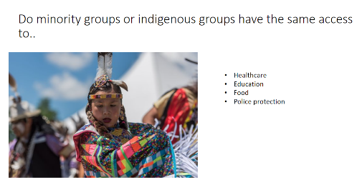
Curriculum Links
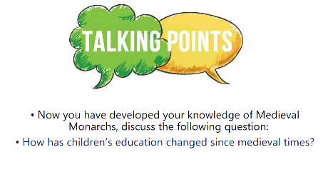
In our school community, we recognise the importance of children’s rights being learnt, practised, respected, protected and promoted.
We now want children and adults to recognise the links with this in all that we do. Our lessons now have links to UNCRC, meaning children are continually making links between the UNCRC and their learning.

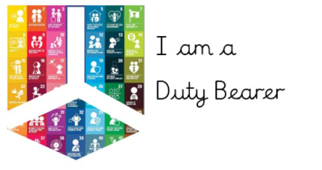
Duty Bearers and Rights Holders
In school, we recognise all adults as Duty Bearers. Duty Bearers are responsible to make children aware of their rights, and act if their rights are not being met.
Children in school are the Rights Holders. We aim to build their capacity as rights holders to be able to claim their rights.

Thank you for your continued support

Mrs A. Askew and the Pupil Leadership Team

